**IBM Report (Nalaiya Thiran)**

**FERTILIZER RECOMNDIATION SYSTEM FOR DISEASE PREDICTION**

# SUBMITTED BY

**(113219041085)**

**PRAKASH S**

PROPOSED SOLUTION FIT AND ARCHITECTURE

**Project Design Phase-I Proposed Solution Fit**

**and Architecture**

|  |  |
| --- | --- |
| Date | 23th September 2022 |
| Team ID | PNT2022TMID23494 |
| Project Name | Fertilizer recommendation system for disease prediction |
| Maximum Marks | 2 Marks |

**Proposed Solution Template:**

Project team shall fill the following information in proposed solution template.

|  |  |  |
| --- | --- | --- |
| **S.No.** | **Parameter** | **Description** |
| 1. | Problem Statement (Problem to be  solved) | *The real problem is the knowledge of Artificial Intelligence limited number of people who are aware of the potential of AI.  * Reduce the workload of the consumer.  * High cost of maintenance. |
| 2. | Idea / Solution description | In general, AI solutions are all about bringing the aspects of intelligence to machine and having them perform tasks that can be natural and easy to humans but extreme complicated to program. |
| 3. | Novelty / Uniqueness | * Obtaining the Artificial intelligence is an computer science in data and analytics. It refers to the ability of hardware or software to acquire and apply the knowledge and think human. So we implemented NPK sensor using AI |
| 4. | Social Impact / Customer Satisfaction | * AI incorporates into customer service is by data collection and analytics.  * The amount of data generated by customer side is vast and can provide valuable insights into customer behavior, preferences, churn rate, and more |
| 5. | Business Model (Revenue Model) | AI business model is a product/service company that leverages its infrastructure, platform  * software to provide applications that enable big data, intelligence, inventory management, |
| 6. | Scalability of the Solution | * High scalability as it is highly efficient and easy implementation. |

**ARCHITECTURE:**

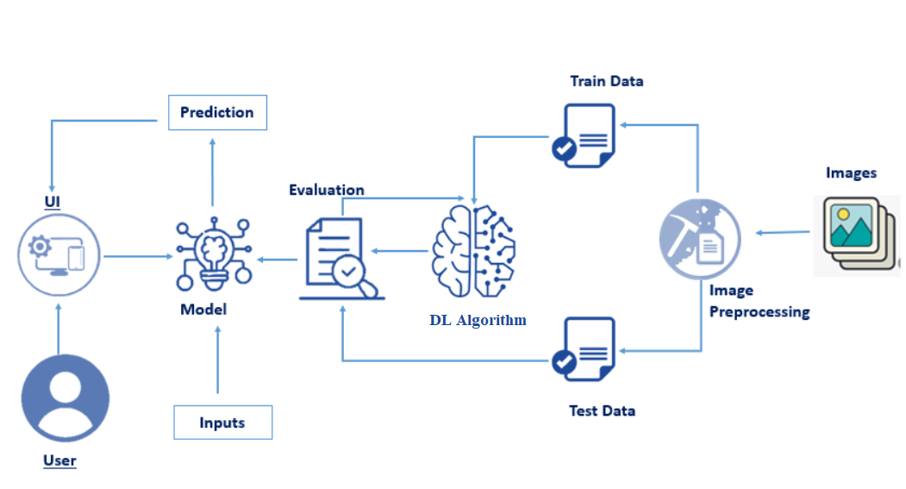***BLOCK DIAGRAM OF FERTILIZER RECOMMENDATION SYSTEM FOR DISEASE PREDICTION***

# ALGORITHM / METHODOLOGY:

**STEP 1:**SOIL requires different amounts of these nutrients at each stage. It is important that you provide your soil with a sufficient amount of NPK and other nutrients.

.

**STEP 2:** At first the user has to measure nutrients amount of soil by using NPK sensor . After measuring the value of soil . The sensor has predetermined value compares with the measured value from soil by Artificial Intelligence algorithm.

**STEP 3**: After comparing two values the AI will intimates the user to crop the plants or fibers according to NPK values.

**STEP 4**: The plants NPK values can be monitored by the AI prediction. The sensor will detect the soil fertility.

,that will detect the plants nutrition level. Nutrition level of nitrogen is 2-10ppm.

Nutrition level of phosphorous is 25-50ppm. Nutrition level of potassium is 40-80 ppm.

**STEP 5**: The moisture level in the soil is detected by the humidity sensor.

**STEP 6**: The water level in the soil is more means it can be separated by heat , temperature sensor.

**STEP 7**: future growth of the plants can be determined by this techniques.

**STEP 8**: The farmer will monitor the soil fertility and other information can be find by NPK sensor.